**COMP 488 – Rapid APP using .NET**

**Professor:** Karim Kabani

**Project Update**

**Project Name**: Chicago Crime Alert Application

**Members**: Carla Robinson, Jack Broncato, Vismark Juarez

**Project Abstract**:

The objective of this application is to inform users of criminal activities occurring within areas they may be interested. The Chicago Crime Alert Application will enable users to sign up for e-mail and text notifications of criminal activity reported within specific Chicago wards. This will allow users a high level of awareness as to what sort of criminal activity (if any) is occurring within a ward/neighborhood specified. Additionally, users of this application will also be able to search for historical crime trends that have occurred within Chicago wards or neighborhoods of interest. The statistics available to users will include metrics on the types of crimes that have been committed in certain wards in Chicago, as well as the frequency with which they occur.

**Features Completed**:

* Connectivity with the Twilio API
* SMS Text sending capability
* MongoDB Cloud Connectivity

**Features to be completed**:

* UI Implementation (Welcome Page, News Page, Crime Stats Page & Sign Up Page)
* Chicago Crime Portal API interactivity

**Issues if any:** None (as of 10/16/2019)

**Project Plan (Schedule/Timeline):**

* 10/25: UI with at least blank pages and a basic navigation pane implemented
* 10/25: Connectivity with the Chicago Crime Portal established (able to retrieve data)
* 10/25: Welcome Page, News Page and Sign Up Page fully implemented
* 11/1: Crime Stats Page should be fully implemented (charts, histograms, etc)
* 11/8: Final testing should be executed.
* 11/15: Application should be fully deployable.

**Screenshots**:

* 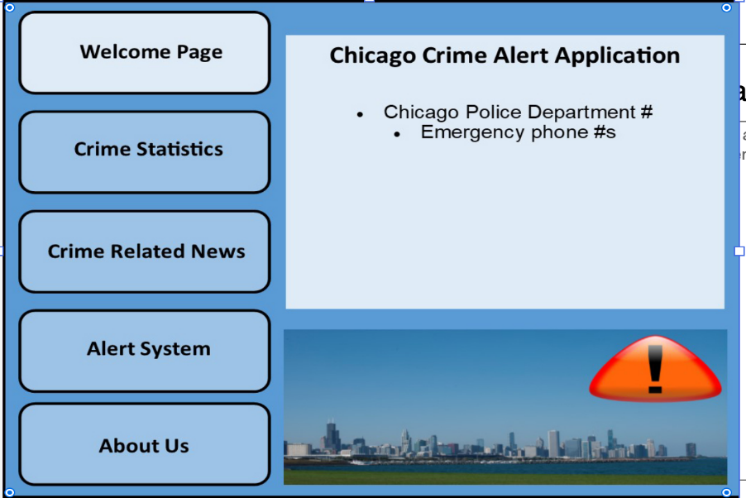Intended UI Home Page Design:
* 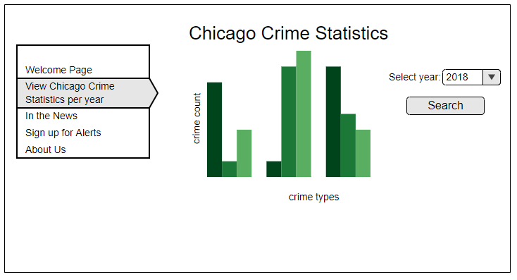Intended Crime Statistics Page:
* Intended Crime News Page:

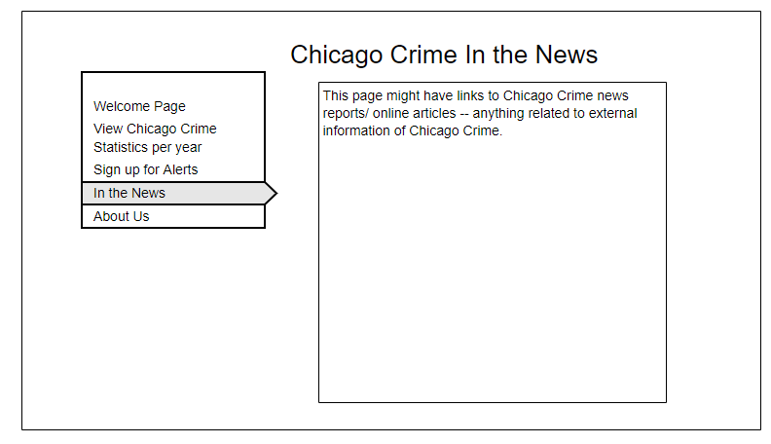

* Intended Alerts Sign Up Page:

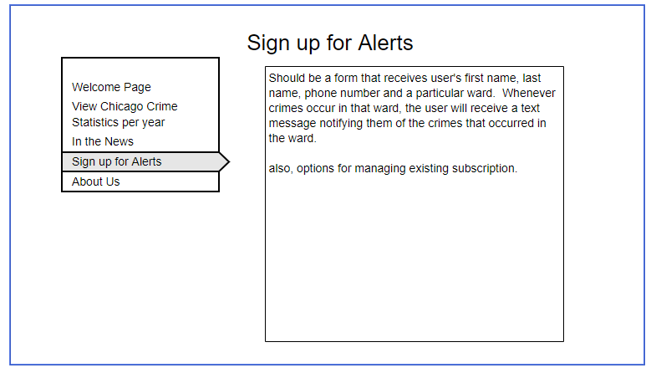

* Intended About Us Page:

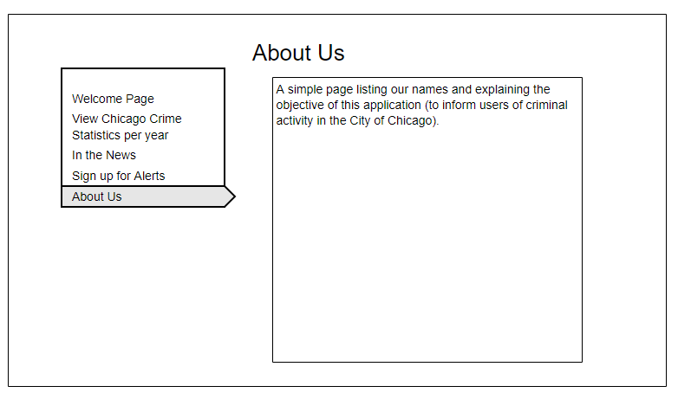

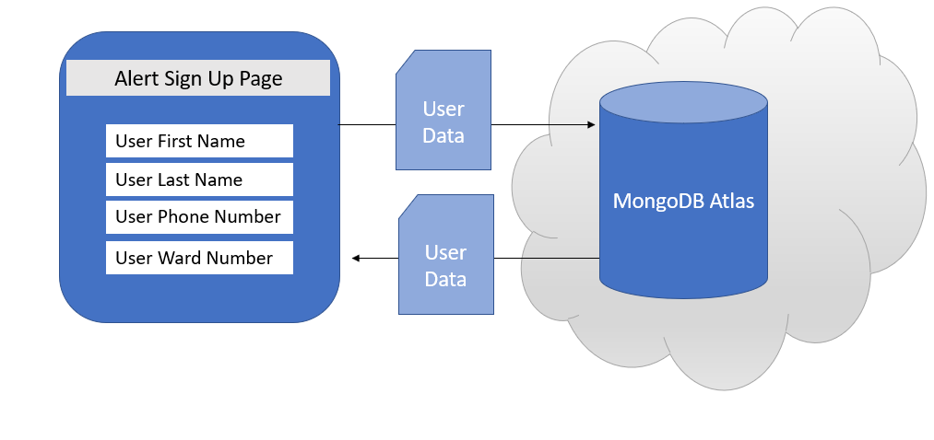**Database Diagram**:

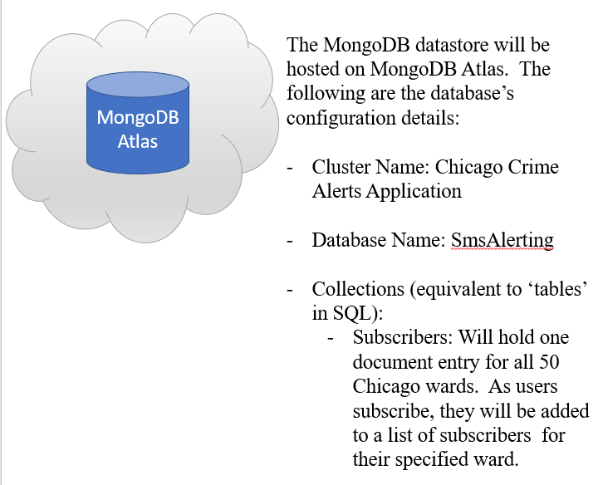

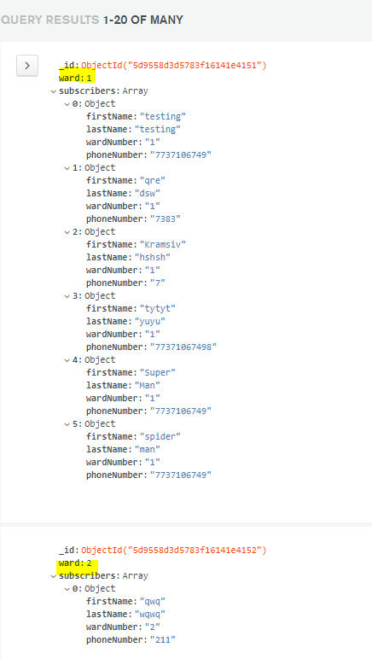

**Couple of lines from each group member on what they have worked on; the entire group have to agree with each other on the work split**:

* **Vismark Juarez**: Set up the application’s back-end connection to the Twilio API to allow for SMS texting capabilities. Also, added MongoDB dependencies to successfully store user data into a MongoDB database running on MongoDB Atlas.
* **Jack Broncato**: Did some basic work on the UI as well as research into how to style windows forms applications, contributed to lite requirements doc.
* **Carla Robinson**: Prototype design of the welcome page. Researching the capturing of the Chicago wards crime data and implementation of the APIs.